COMPILER DESIGN LAB
MINI-PROJECT

RING PARSER

Section A
Saswat Levin
Royston Buthello

INDEX

- Introduction to the Language
- Implementation Details
- Keywords
- Grammar
- Flex Code
- Bison Code
- Sample Output
- References

INTRODUCTION TO THE LANGUAGE

Ring is a dynamically typed, general-purpose programming language. It can be embedded in C/C++ projects, extended using C/C++ code and/or used as a standalone language. The supported programming paradigms are imperative, procedural, object-oriented, functional, meta, declarative using nested structures, and natural programming. The language is portable (Windows, Linux, macOS, Android, etc.) and can be used to create Console, GUI, Web, Gaming and Mobile applications.

The language is designed to be simple, compact, flexible and fast. It is a Dynamic Language (Dynamic Typing and Weakly Typed) that compiles the source code to byte code then execute it by the Ring Virtual Machine, which is integrated with the Ring Compiler in one program.

Due to the complexity involved in integrating a VM into the compiler and the limited scope of the mini-project, it was not a focus during the parser’s creation.

It should be noted that that Ring is not case-sensitive, and has a very flexible syntax that even allows renaming of keywords, and uses lexical scoping rather than dynamic scoping, making parts of the implementation simpler while making other parts far more complicated.

The goal of this mini-project is to develop a compiler for the Ring language upto the parsing phase confirming to the Ring 1.10 standard. The different parts of the project will be implemented by coding in C and using automatic lexer and parser generators like FLEX and BISON.

IMPLEMENTATION DETAILS

The pseudo-compiler we developed makes use of bottom-up parsing. It consists of two components: a lexer which scans tokens from the input file and returns them to the parser, in turn uses the values from those tokens to parse the appropriate grammar productions.

If a token is expected and it isn’t found, then it prints the error occurred with the line number at which the error occurred, along with the correct token that was expected.

Tools:-
- Lexical Analyzer and Parser-Generation tools: Flex and Bison
- C Language
- C18 Standard
- Bottom-Up Parser

Execution:-
- bison -d ring.y
- flex ring.l
- gcc lex.yy.c ring.tab.c -o output

KEYWORDS
Keywords Count : 49
- again
- and | or | not | but
- bye
- call
- switch | case
- changeringkeyword | changeringoperator
- class | endclass
- def
- done
- if | else | elseif
- end
- exit
- for | while | do | loop
- from
- func | endfunc
- get | put
- give
- import
- in
- load
- loadsyntax
- new
- next
- on | off
- ok
- other
- package | endpackage
- private
- return
- see
- step
- to
- try | catch

GRAMMAR

Program —> {statement}

Statement —> ‘package’ <Identifier> { ‘.’ <Identifier> } [‘{‘ {statement} ‘}’] [‘end’|’endpackage’]

Statement —> ‘class’ <Identifier> [ ‘from’|’:’|’<’ <Identifier> ] [‘{‘ {statement} ‘}’][‘end’|’endclass’]

Statement —> ‘func’|’def’ <Identifier> [ParaList] [‘{‘ {statement} ‘}’][‘end’|’endfunc’]

Statement —> ‘import’ <Identifier> { ‘.’ <Identifier> }

Statement —> ‘private’

Statement —> ‘load’ [‘package’] <Literal>

Statement —> ‘loadsyntax’ <Literal>

Statement —> ‘changeringkeyword’ <OldKeyword> <NewKeyword>

Statement —> ‘changeringoperator’ <OldOperator> <NewOperator>

Statement —> ‘see’|’put’ <Expr>

Statement —> ‘give’|’get’ <Identifier>

Statement —> ‘if’ <Expr> [‘{‘] {statement} [ {‘but’|’elseif’ <Expr> {Statement} } ] [‘else’ {Statement} ] ‘ok’|’end’|’}’

Statement —> ‘Switch’ <Expr> [‘{‘] { ‘on’|’case’ <Expr> {statement} } [‘other’ {Statement} ] ‘off’|’end’|’}’

Statement —> ‘for’ <Identifier> ‘=’ <Expr> ‘to’ <Expr> [ ‘step’ <Expr> ] [‘{‘] {Statement} ‘next’|’end’|’}’

Statement —> ‘for’ <Identifier> ‘in’ <Expr> [ ‘step’ <Expr> ] [‘{‘] {statement} ‘next’|’end’|’}’

Statement —> ‘while’ <Expr> [‘{‘] {statement} ‘end’|’}’

Statement —> ‘do’ {statement} ‘again’ <Expr>

Statement —> ‘try’ {statement} [‘{‘] ‘catch’ {statement} ‘done’|’end’|’}’

Statement —> ‘return’ <Expr>

Statement —> ‘bye’

Statement —> ‘exit’

Statement —> ‘loop’

Statement —> <Expr>

Statement —> epslion

ParaList —> epslion

ParaList —> [‘(‘] <Identifier> [{ ‘,’ <Identifier> }] [‘)’]

Expr —> <LogicNot> [{ ‘and’|’or’ <LogicNot> }]

LogicNot –> [‘not’] <EqualOrNot>

EqualOrNot –> [ ‘=’|’!=’ ] <Compare>

Compare —> <BitOrXor> [ { ‘<’ | ‘>’ | ‘<=’ | ‘>=’ <BitOrXor> } ]

BitOrXor —> <BitAnd> [ { ‘|’ | ‘^’ <BitAnd> } ]

BitAnd —> <BitShift> [ { ‘&’ <BitShift> } ]

BitShift —> <Arithmetic> [ { ‘<<’ | ‘>>’ <Arithmetic> } ]

Arithmetic —> <Term> [ { ‘+’ | ‘-‘ <Term> } ]
Term —> <Range> [ { ‘*’ | ‘/’ | ‘%’ <Range> } ]

Range —> <Factor> [ ‘:’ <Factor> ]

Factor —> <Identifier> [ {Mixer} ] [ ‘=’ <Expr> ]

Factor —> <Number>

Factor —> <Literal>

Factor —> ‘:’ <Identifier>

Factor —> ‘-‘ <Factor>

Factor —> ‘(‘ <Expr> ‘)’

Factor —> <List>

Factor —> ‘new’ <Identifier>

Factor —> <AnonymousFunction>

Factor —> ‘call’ <identifier> { ‘.’ <Identifier> } ‘(‘ <Parameters> ‘)’

List —> ‘[‘ [ <Expr> { ‘,’ <Expr> } ] ‘]’

Mixer —> { ‘.’ <Identifier> }

Mixer —> ‘[‘ <Expr> ‘]’

Mixer —> ‘(‘ [ <Expr> [ { ‘,’ <Expr> }] ] ‘)’

Mixer —> ‘{‘ {Statement} ‘}’

AnonymousFunction —> ‘func’|’def’| [<ParaList>] ‘{‘ {Statement} ‘}’

FLEX CODE

//ring.l
%{
#include "ring.tab.h"
char arr[100];
int i = 0;
int flag = 0;
%}

%%
"if" {yylval.str = strdup(yytext);return IF;}
"else" {yylval.str = strdup(yytext);return ELSE;}
"elseif" {yylval.str = strdup(yytext);return ELSEIF;}

"+" {yylval.str = strdup(yytext);return OPERATOR;}
"-" {yylval.str = strdup(yytext);return OPERATOR;}
"*" {yylval.str = strdup(yytext);return OPERATOR;}
"/" {yylval.str = strdup(yytext);return OPERATOR;}
"%" {yylval.str = strdup(yytext);return OPERATOR;}
"<" {yylval.str = strdup(yytext);return OPERATOR;}
"<=" {yylval.str = strdup(yytext);return OPERATOR;}
">" {yylval.str = strdup(yytext);return OPERATOR;}
">=" {yylval.str = strdup(yytext);return OPERATOR;}
"=" {yylval.str = strdup(yytext);return OPERATOR;}
"|" {yylval.str = strdup(yytext);return OPERATOR;}
"^" {yylval.str = strdup(yytext);return OPERATOR;}
"&" {yylval.str = strdup(yytext);return OPERATOR;}
"and" {yylval.str = strdup(yytext);return OPERATOR;}
"or" {yylval.str = strdup(yytext);return OPERATOR;}
"not" {yylval.str = strdup(yytext);return OPERATOR;}

"for" {yylval.str = strdup(yytext);return FOR;}
"to" {yylval.str = strdup(yytext);return TO;}
"step" {yylval.str = strdup(yytext);return STEP;}

"func" {yylval.str = strdup(yytext);return FUNC;}
"endfunc" {yylval.str = strdup(yytext);return ENDFUNC;}

"while" {yylval.str = strdup(yytext);return WHILE;}
"end" {yylval.str = strdup(yytext);return END;}

"do" {yylval.str = strdup(yytext);return DO;}
"again" {yylval.str = strdup(yytext);return AGAIN;}

"try" {yylval.str = strdup(yytext);return TRY;}
"catch" {yylval.str = strdup(yytext);return CATCH;}

"switch" {yylval.str = strdup(yytext);return SWITCH;}
"case" {yylval.str = strdup(yytext);return CASE;}
"other" {yylval.str = strdup(yytext);return OTHER;}

"package" {yylval.str = strdup(yytext);return PACKAGE;}
"." {yylval.str = strdup(yytext);return DOT;}
"endpackage" {yylval.str = strdup(yytext);return ENDPACKAGE;}

"see" {yylval.str = strdup(yytext);return SEE;}

"give" {yylval.str = strdup(yytext);return GIVE;}

"class" {yylval.str = strdup(yytext);return CLASS;}
"from" {yylval.str = strdup(yytext);return FROM;}
"endclass" {yylval.str = strdup(yytext);return ENDCLASS;}

"load" {yylval.str = strdup(yytext);return LOAD;}

"\""([^\n\"\\]*(\\[.\n])*)*"\"" {yylval.str = strdup(yytext);return LITERAL;}

"{" {yylval.str = strdup(yytext);return LBR;}
"}" {yylval.str = strdup(yytext);return RBR;}

"(" {yylval.str = strdup(yytext);return LR;}
")" {yylval.str = strdup(yytext);return RR;}

"," {yylval.str = strdup(yytext);return COMMA;}

"@" {yylval.str = strdup(yytext);return EOP;}

[aA-zZ_0-9]+ {yylval.str = strdup(yytext);return IDENTIFIER;}

%%
void yyerror(char *msg) {
printf("error\n");
// printf("%s\n", msg);

printf("line number: %d, msg: %s, char: %s\n", yylineno, msg, yytext );
}

int yywrap()
{
return 1;
}

BISON CODE

//ring.y
%{
#include<stdio.h>
#include<stdlib.h>
int yylex();
int yyerror();
extern FILE *yyin;
extern char arr[100];
extern int i;
%}

%union { char *str;}

%token <str>IF
%token <str>ELSE
%token <str>ELSEIF

%token <str>FOR
%token <str>TO
%token <str>STEP

%token <str>FUNC
%token <str>ENDFUNC

%token <str>WHILE
%token <str>END

%token <str>DO
%token <str>AGAIN

%token <str>TRY
%token <str>CATCH

%token <str>SWITCH
%token <str>CASE
%token <str>OTHER

%token <str>PACKAGE
%token <str>DOT
%token <str>ENDPACKAGE

%token <str>SEE
%token <str>LITERAL

%token <str>GIVE

%token <str>CLASS
%token <str>FROM
%token <str>ENDCLASS

%token <str>LOAD

%token <str>IDENTIFIER
%token <str>OPERATOR

%token <str>LBR
%token <str>RBR

%token <str>COMMA

%token <str>LR
%token <str>RR

%token <str>EOP
%define parse.error verbose

%%
stmt:program EOP ;

program:Statement;

Statement:if_statement
|for_loop
|function_statement
|while_loop
|do_again_loop
|try_catch_statement
|switch_statement
|package_statement
|see_statement
|give_statement
|class_statement
|load_statement
|expr ;

if_statement:IF expr lbr_d stmt_prime_4 elseif_expr_stmt_p else_STMT_d RBR Statement;

for_loop:FOR expr TO expr step_expr_d lbr_d2 STMT_prime_3 RBR Statement;

while_loop:WHILE expr lbr_d4 stmt_prime_7 RBR Statement ;

do_again_loop:DO stmt_prime_8 AGAIN expr Statement ;

try_catch_statement:TRY stmt_prime_9 lbr_d5 CATCH stmt_prime_10 RBR Statement;

switch_statement:SWITCH expr lbr_d1 case_expr_statement_p other_STMT_d RBR Statement;

package_statement:PACKAGE IDENTIFIER dot_id_p lbr_stmt_rbr_d ENDPACKAGE Statement ;

see_statement:SEE expr Statement | SEE LITERAL Statement;

give_statement:GIVE expr Statement | GIVE LITERAL Statement ;

class_statement:CLASS IDENTIFIER from_colon_lt_id_prime lbr_stmt_rbr_d1 ENDCLASS Statement;

load_statement:LOAD PACKAGE LITERAL;

from_colon_lt_id_prime:FROM IDENTIFIER | ;

lbr_stmt_rbr_d1: LBR stmt_prime_2 RBR | ;

stmt_prime_2:stmt_prime_2 IDENTIFIER | stmt_prime_2 expr | ;

dot_id_p:DOT IDENTIFIER dot_id_p | ;

lbr_stmt_rbr_d:LBR stmt_prime_1 RBR | ;

stmt_prime_1:stmt_prime_1 IDENTIFIER | stmt_prime_1 expr | ;

lbr_d1:LBR | ;

case_expr_statement_p:case_expr_statement_p CASE expr stmt_prime_5 | ;

other_STMT_d:OTHER STMT_prime_2 | ;

STMT_prime_2:STMT_prime_2 Statement | ;

stmt_prime_5:stmt_prime_5 IDENTIFIER |stmt_prime_5 expr | ;

stmt_prime_9:stmt_prime_9 IDENTIFIER |stmt_prime_9 expr | ;

lbr_d5:LBR | ;

stmt_prime_10:stmt_prime_10 IDENTIFIER |stmt_prime_10 expr | ;
stmt_prime_8:stmt_prime_8 IDENTIFIER |stmt_prime_8 expr | ;

lbr_d4:LBR | ;

stmt_prime_7:stmt_prime_7 IDENTIFIER |stmt_prime_7 expr | ;

function_statement:FUNC IDENTIFIER paralist_d lbr_stmt_rbr_d2 ENDFUNC Statement ;

paralist_d:lr_d IDENTIFIER COMMA IDENTIFIER rr_d | ;

lr_d:LR | ;

rr_d:RR | ;

lbr_stmt_rbr_d2:LBR stmt_prime_3 RBR | ;

stmt_prime_3:stmt_prime_3 IDENTIFIER | stmt_prime_3 expr | ;

step_expr_d:STEP expr | ;

lbr_d2:LBR | ;

STMT_prime_3:STMT_prime_3 Statement | ;

lbr_d:LBR | ;

stmt_prime_4:stmt_prime_4 IDENTIFIER | stmt_prime_4 expr | ;

elseif_expr_stmt_p:elseif_expr_stmt_p ELSEIF expr STMT_p | ;

STMT_p:STMT_p Statement | ;

else_STMT_d:ELSE STMT_prime_1 | ;

STMT_prime_1:STMT_prime_1 Statement | ;
expr:IDENTIFIER OPERATOR IDENTIFIER ;
%%
#ifdef YYDEBUG
yydebug = 1;
#endif

void main()
{
yyin=fopen("test.txt","r");

do
{
if(yyparse())
{
printf("\nFailure:\n");
exit(0);
}
}while(!feof(yyin));

printf("\nSuccess\n");
return 0;
}

SAMPLE PARSING OUTPUT

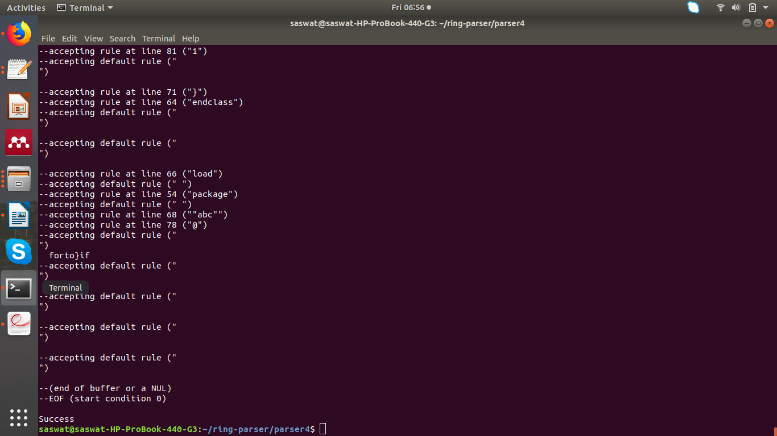

REFERENCES

flex & bison: Text Processing Tools 1st Edition – John Levine

http://ring-lang.sourceforge.net/doc1.10/index.html

